PERSONAL INFORMATION | May Karman
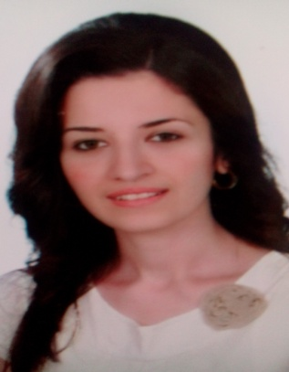 |   From ALEPPO , lived in Aleppo , Syria

0215217523  0988984285

maykarman22@gmail.com

none
 | Sex Female | Date of birth 20/6/1986 | Nationality Syrian

JOB APPLIED FOR | Pharmacist

WORK EXPERIENCE

 | (2020 -present) |  | Pharmaciest  - PhD student in Food and Analytical Chemistry Department  Pharmacy Collage-University of Aleppo  - Lecturer at Alhuash Private university (HPU) in analytical chemistry Department
(2015 -2020) |  | Pharmaciest
- Lecturer at Alhuash Pharmacy university(HPU) in Pharmaceutical and Analytical Chemistry Department
- Manager of Quality Office
- Pharmacist at pharmacy ( at evening shift ) have experience in managing pharmacy and preparing medical preparations
 |  | Business or sector High Education sector – Health sector

(June 2014 – June 2015) | Pharmaciest
 | Worked at pharmacy
 | Business or sector Health sector
(July 2008 - 2013) | Pharmaciest
Worked at Rasha laboratories for Pharmaceutical Industries in suppository and syrup departments
Worked as lecturer at Aleppo University in Food and Analytical Department.
(September 2011 – May 2014)  (2020-2024)  (September 2003 – June 2008 ) | Master in Applied Analytical Chemistry  Thesis Title : ( Determination Of Almotriptan malate in ----Pharmaceutical Formulations Via New spectrophotometric)  Published at researches Journal of Aleppo University/ Medical Sciences Series:  -(Determination of Almotriptan malate in Dosage Forms by Extractive Spectrophotometric Analysis Using Calcon Dye) volume [92] / November,2013 /  - (Spectrophotometric Determination of Almotriptan malate in Pure and Dosage Forms By 2,3 Dichloro 5,6 dicyano 1,4 benzoquinone) volume [94] / May,2014/  PhD student in Applied Analytical Chemistry  Thesis Title : ( New Spectrophotometric Methods for Determination of New Combinations of One of Beta Blockers)  Published at Research Journal of Pharmacy and Technology (Q2)  (Three spectrophotometric methods validated for handling of overlapped spectra : application for determination Propranolol hydrochloride and Hydrochlorothiazide in dosage forms and spiked biological fluids) .  Published at Spectrochimica Acta - Part A: Molecular and Bimolecular Spectroscopy Journal. (Q1)  (Eco-Friendly and Smart Spectrophotometric approaches for Quality Control Analysis of one of β-blockers in their dosage ) .  Submitted at Heliyon journal (Q1)  "Smart fluorescence spectroscopy for resolving analytical challenge of one antimigraine combination in dosage and spiked biological fluids: Greenness and whiteness Assessment. "  Master grade : 89.64%  Bachelor Of Pharmacy and Pharmaceutical Chemistry at University of Aleppo.  Graduation project: Drug eluted stents.  Graduation grade: 72.98%
  EDUCATION AND TRAINING
PERSONAL SKILLS
Mother tongue(s) | Arabic
Other langauge | English ( Advanced )

